# CSA ASSIGNMENT

**Name- Pranav Gurditta**

**Roll number- 2K15/CS/2002**

**Course- BSc. (H) Computer Science**

**Subject- Computer system architecture**

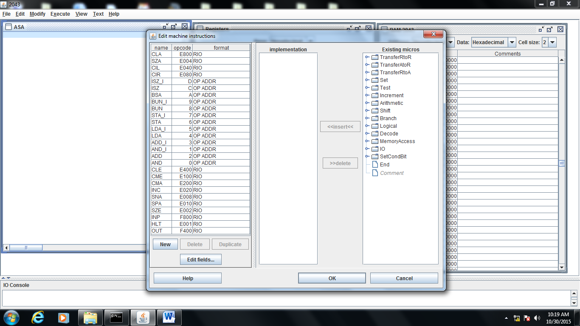

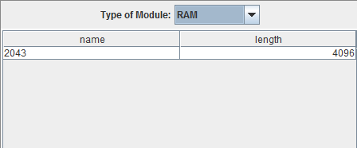

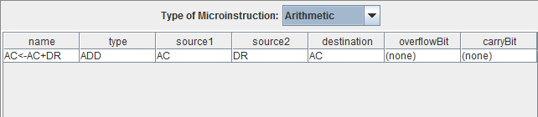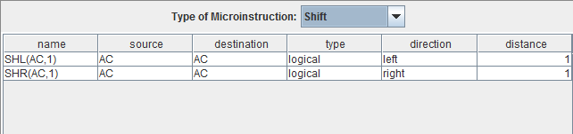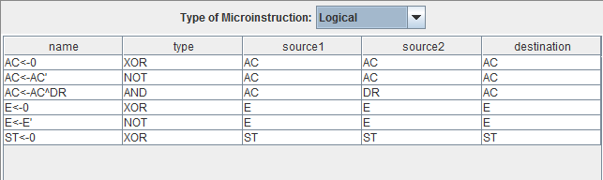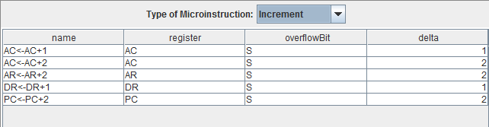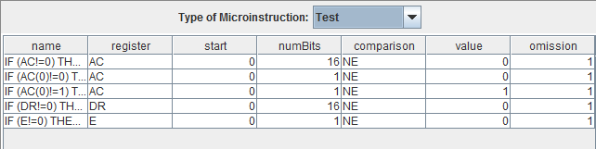LIST OF MICRO-INSTRUCTIONS IN DIFFERENT CATEGORIES

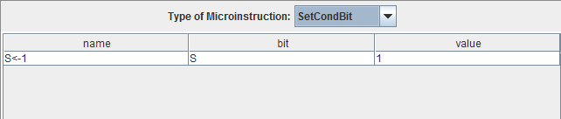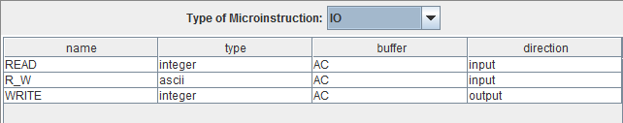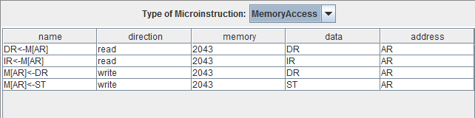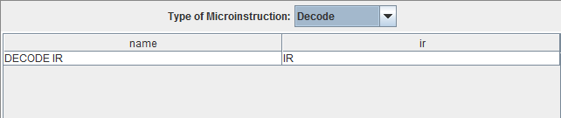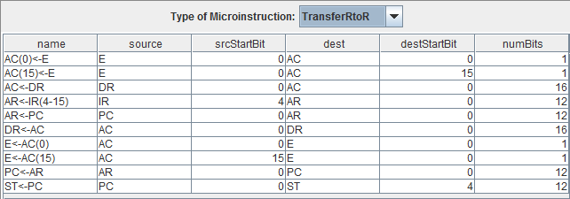

REGISTERS

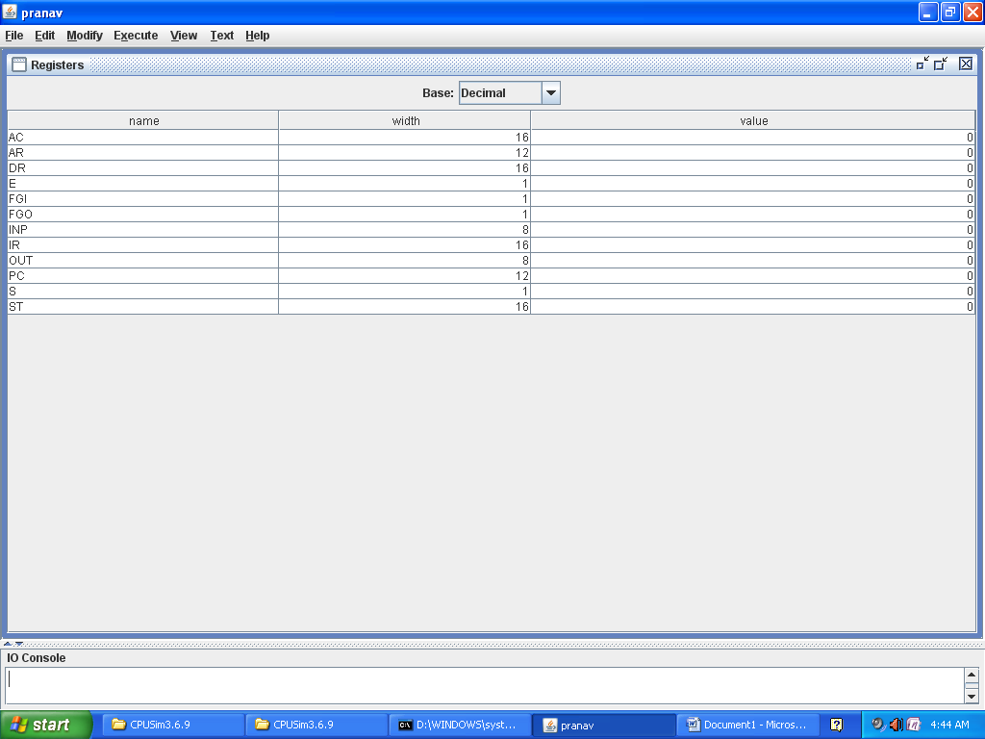

RAM(MEMORY)

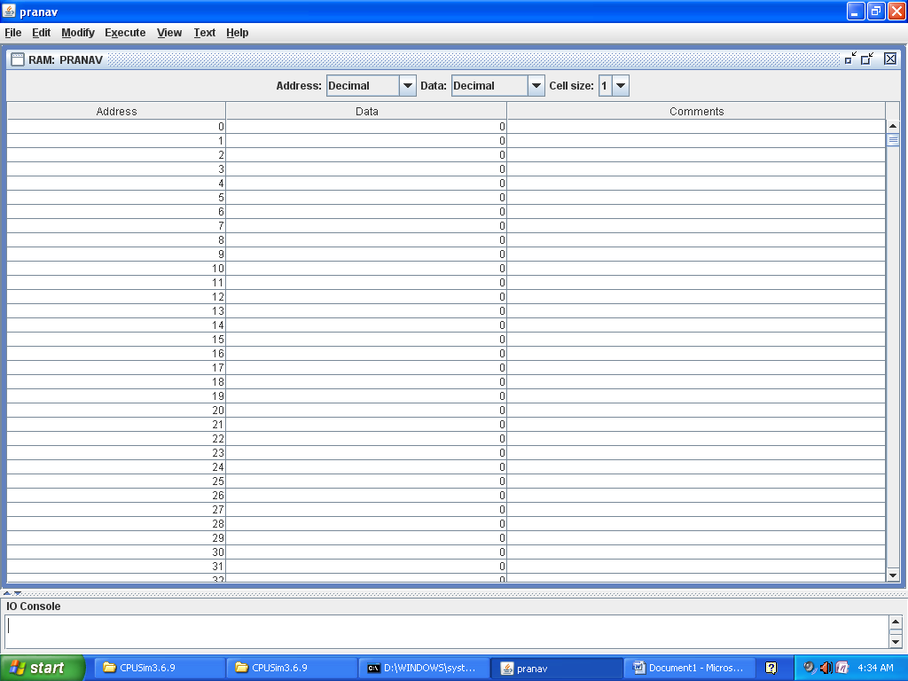

**SET CONDITION BIT**

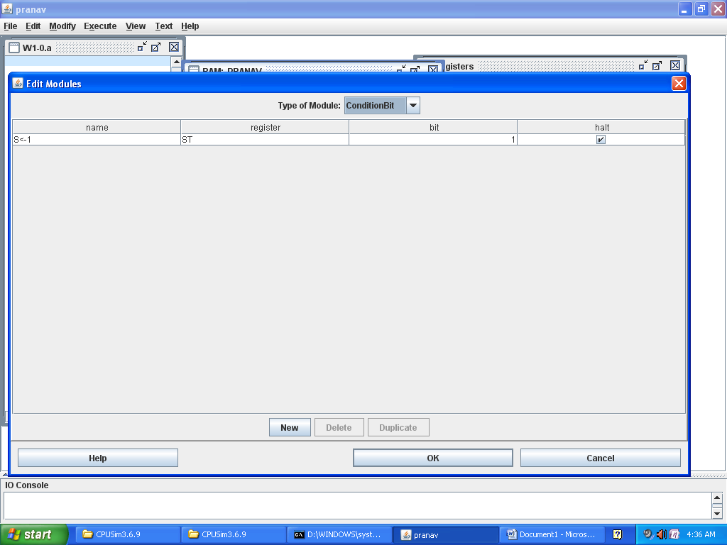

**QUESTION NO 2**

FETCH SEQUENCE

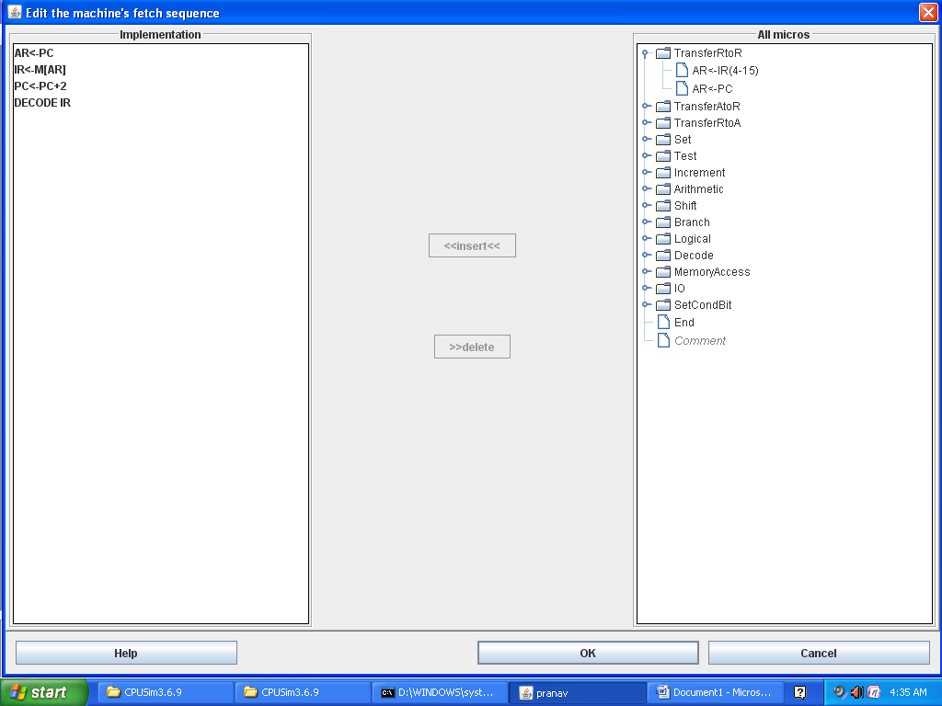

***QUESTION NO 3***

***DIRECT MACHINE***

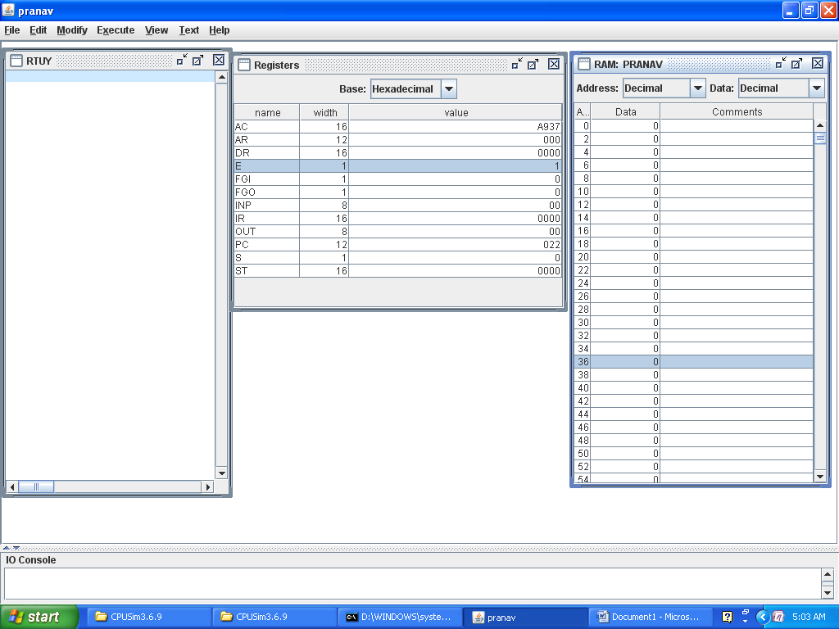

* + 1. **CLA**

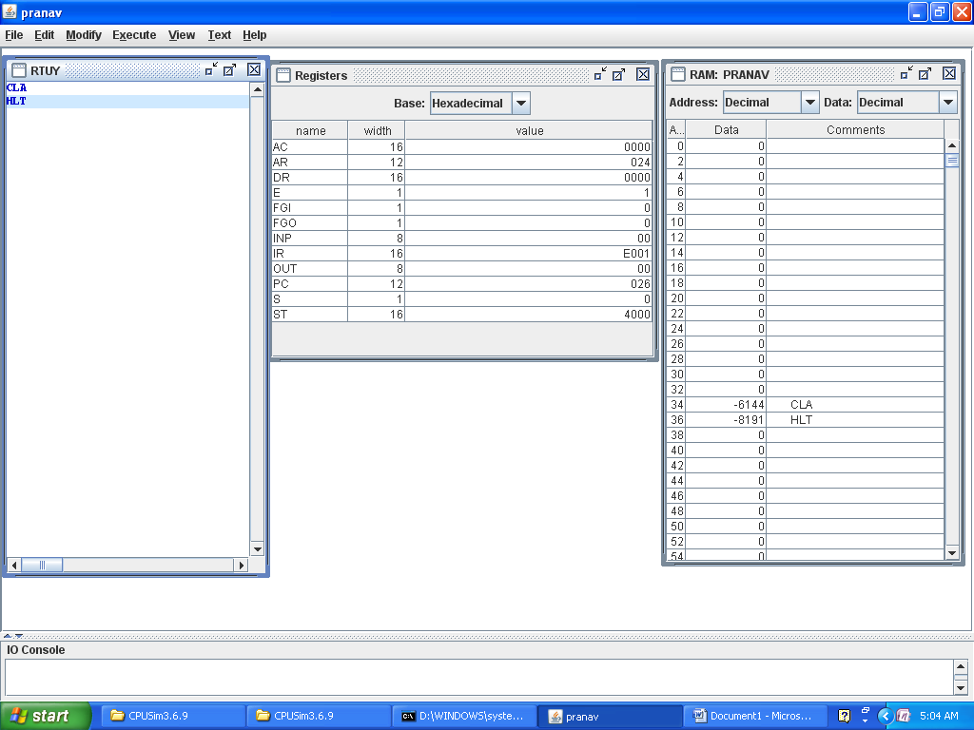

* + 1. **CLE**

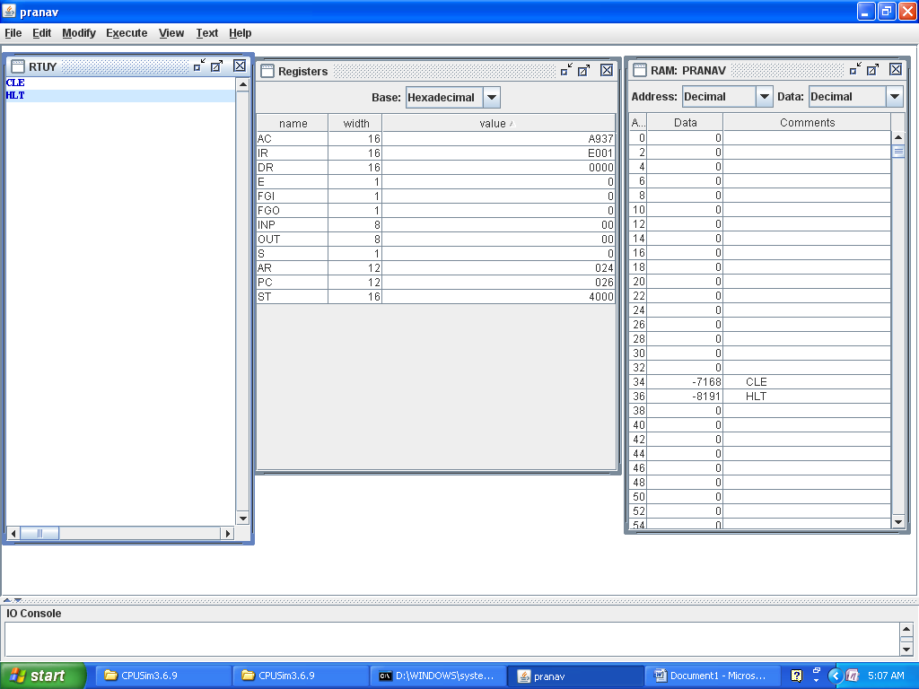

* + 1. **CMA**

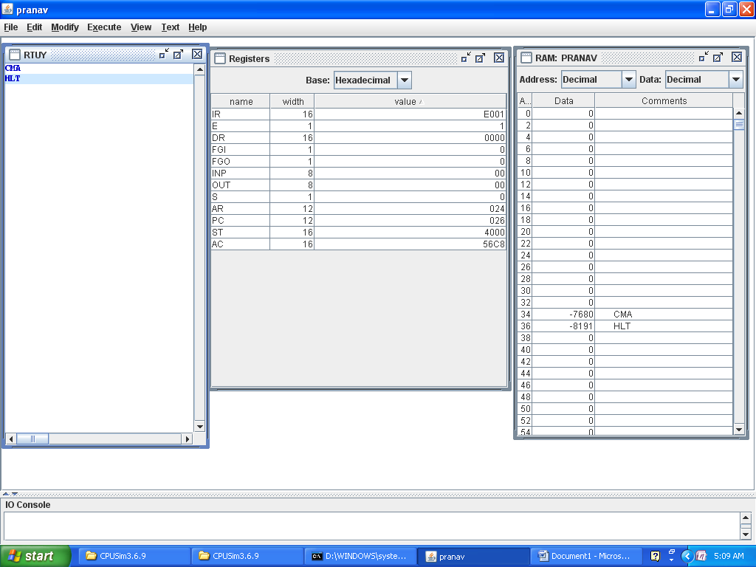

* + 1. **CME**

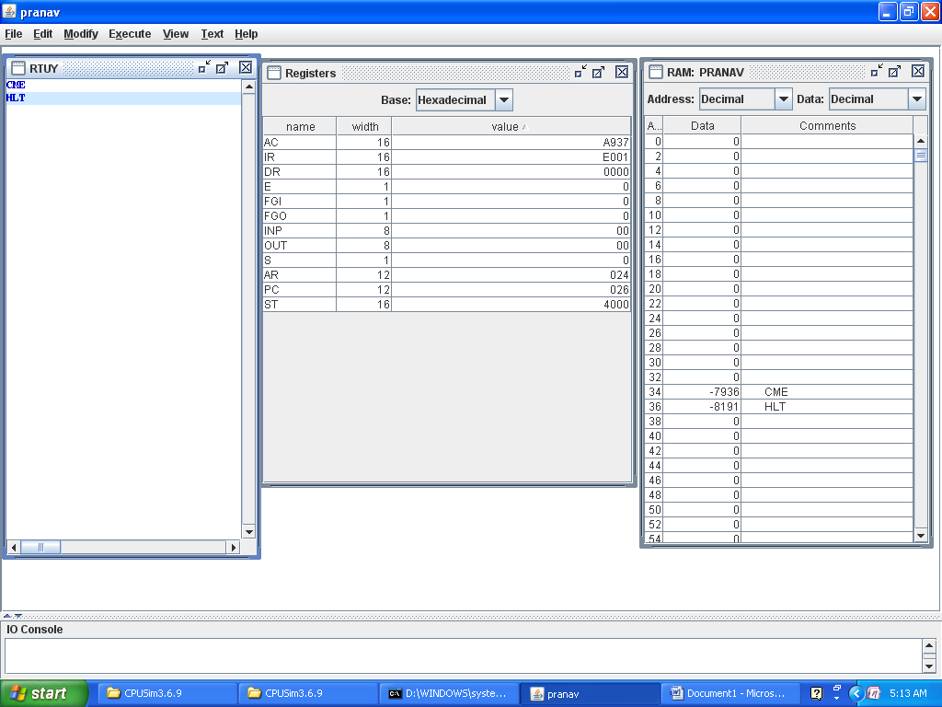

* + 1. **CIR**

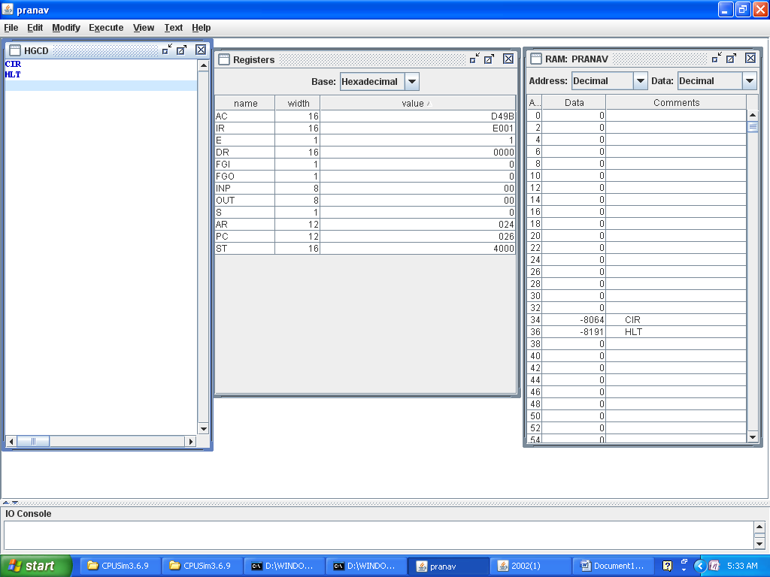

* + 1. **CIL**

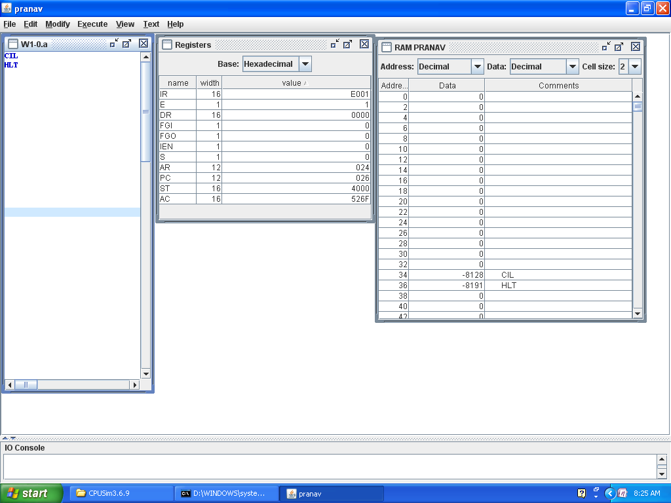

* + 1. **INC**

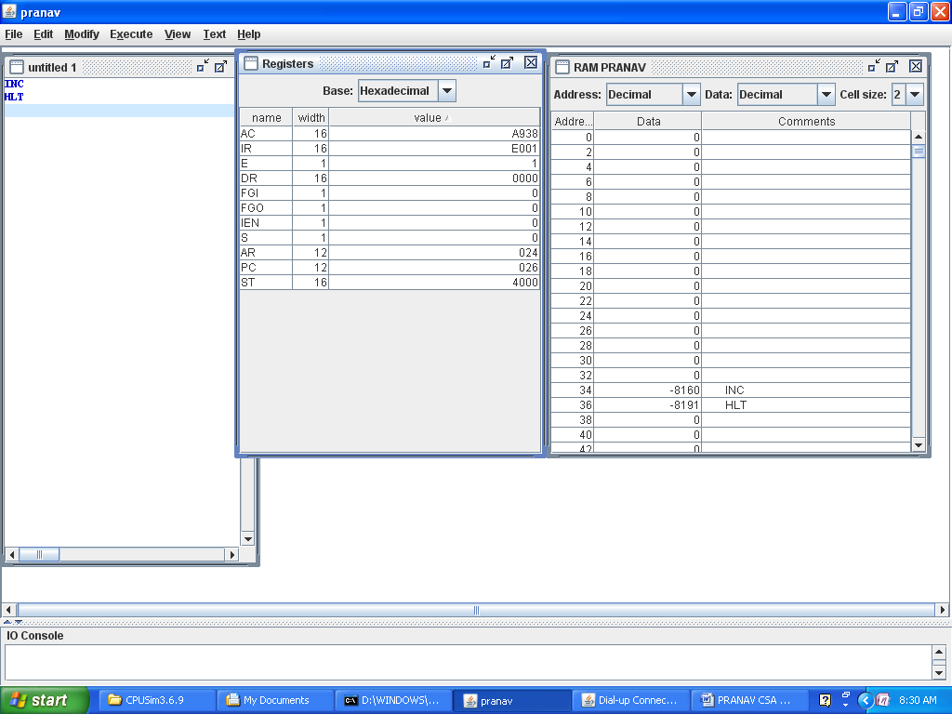

* + 1. **SPA**

**(SPA**

**CLA**

**HLT)**

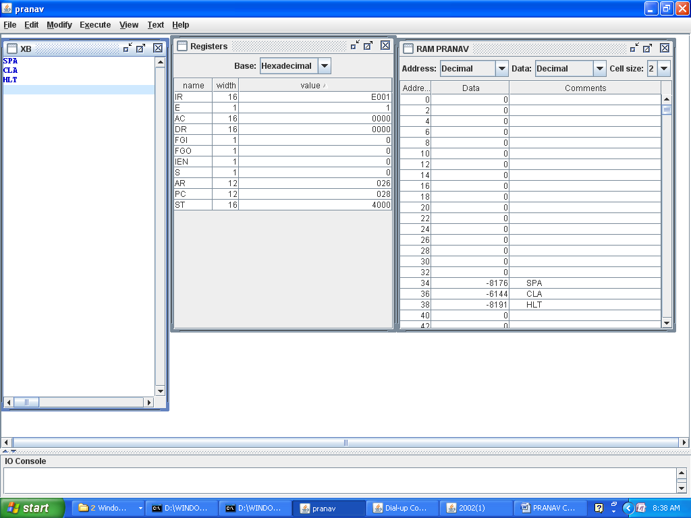

* + 1. **SNA**

**(SNA**

**CLA**

**HLT)**

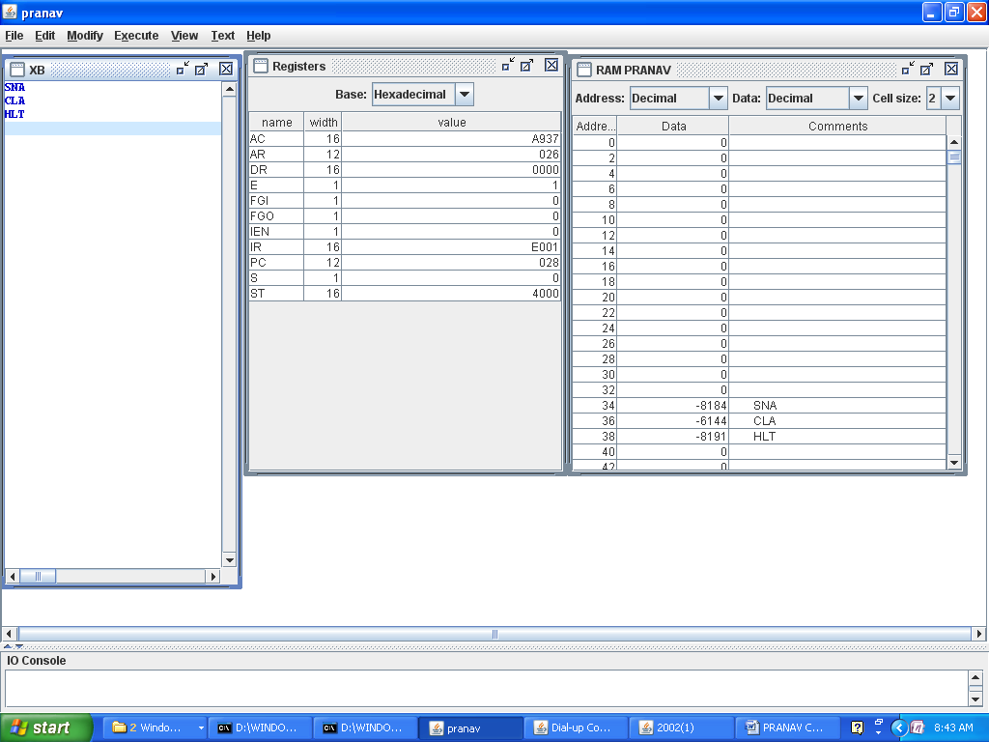

* + 1. **SZA**

**(SZA**

**INC**

**HLT)**

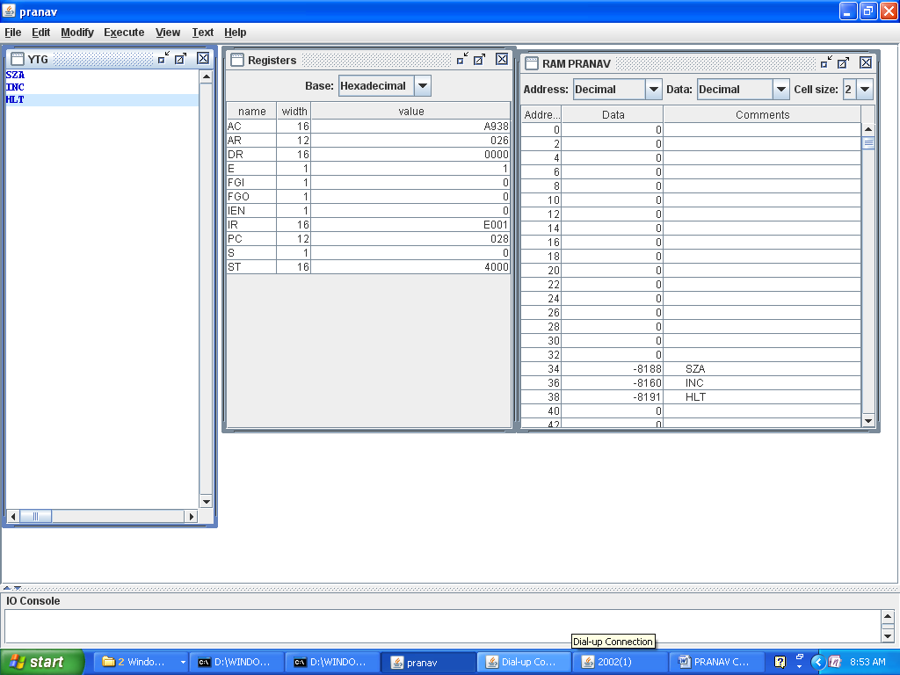

* + 1. **SZE**

**(SZE**

**INC**

**HLT)**

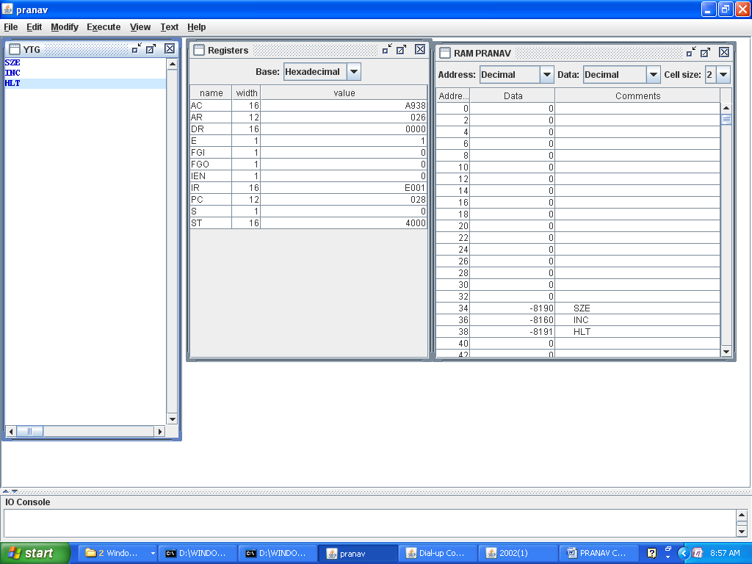

* + 1. **HLT**

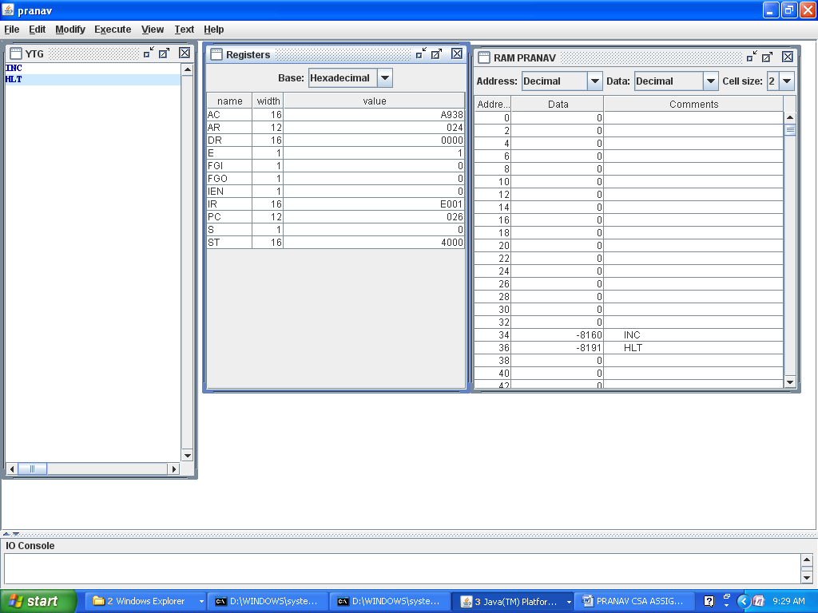

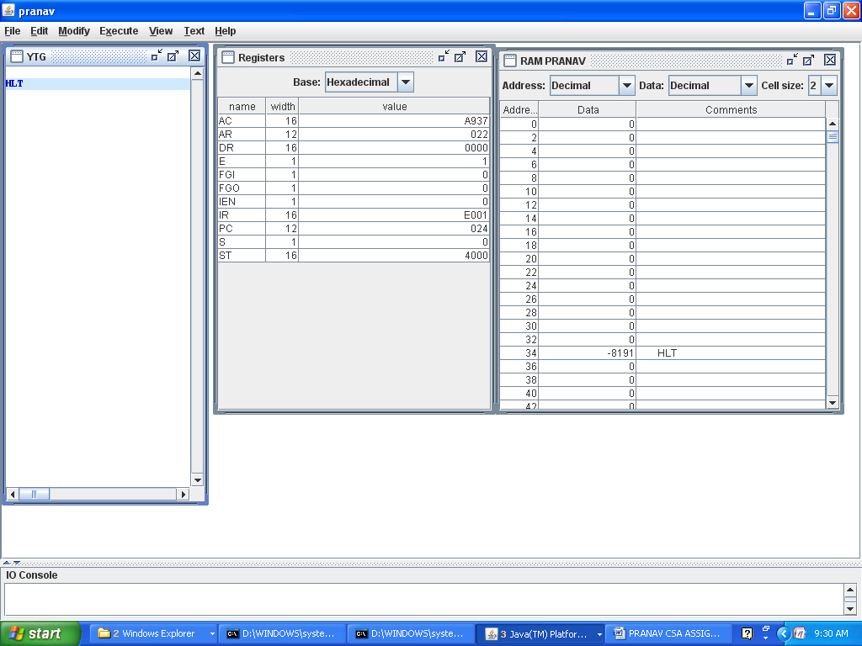

**QUESTION NO 4**

**BEFORE EXECUTION**

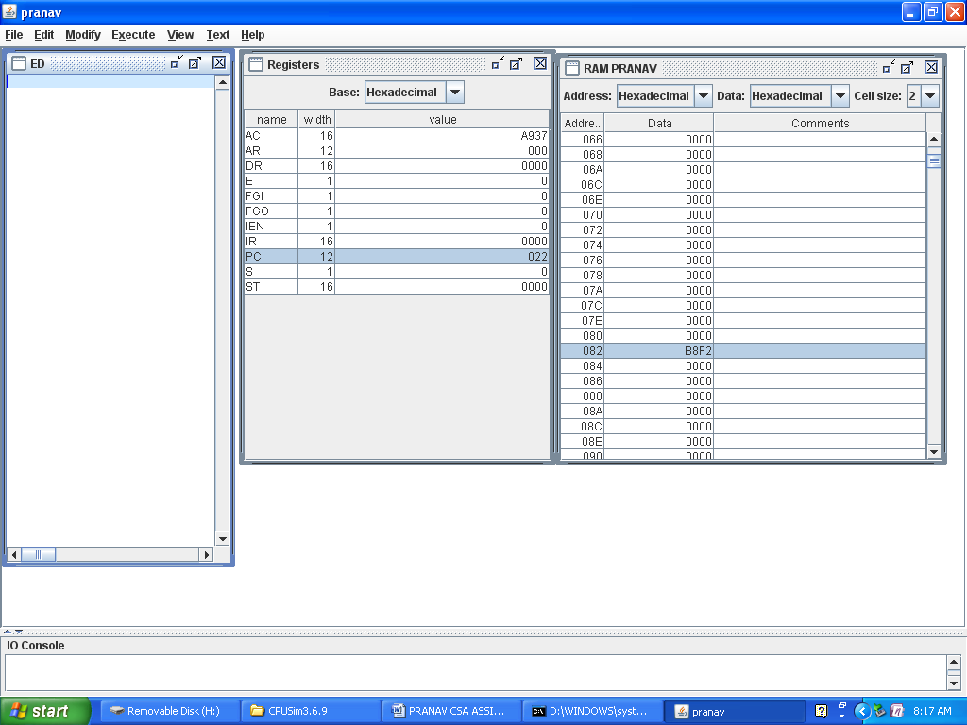

1. **ADD**

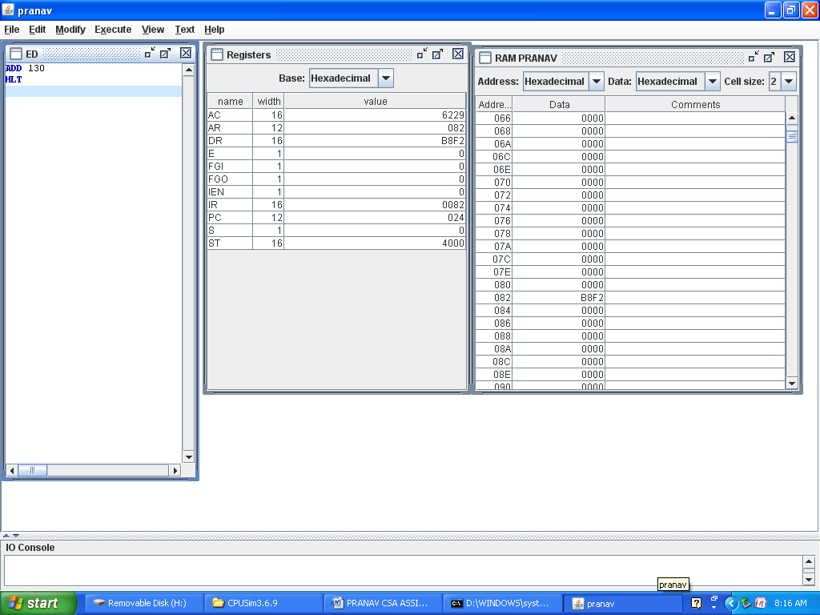

1. **AND**

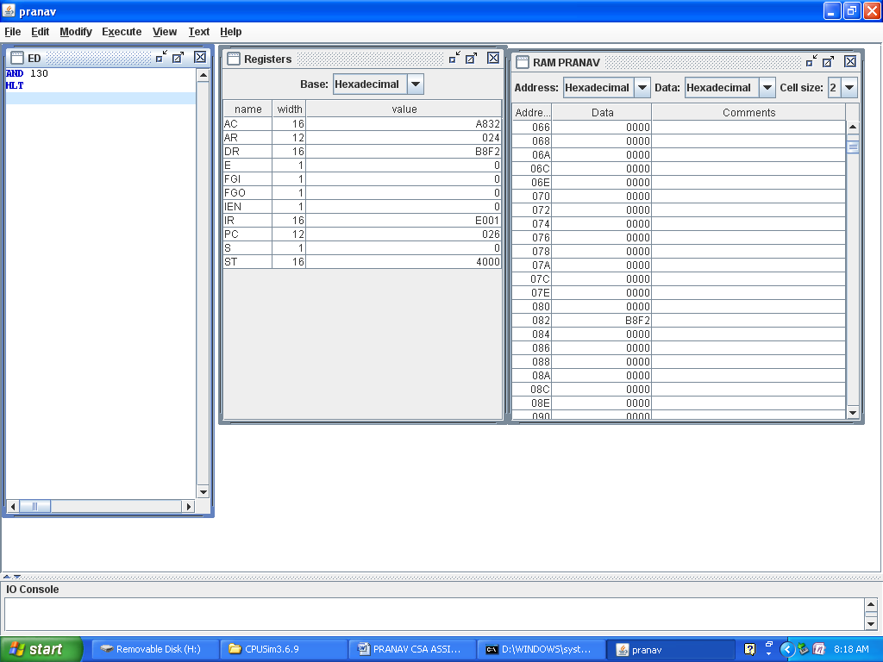

**c.LDA**

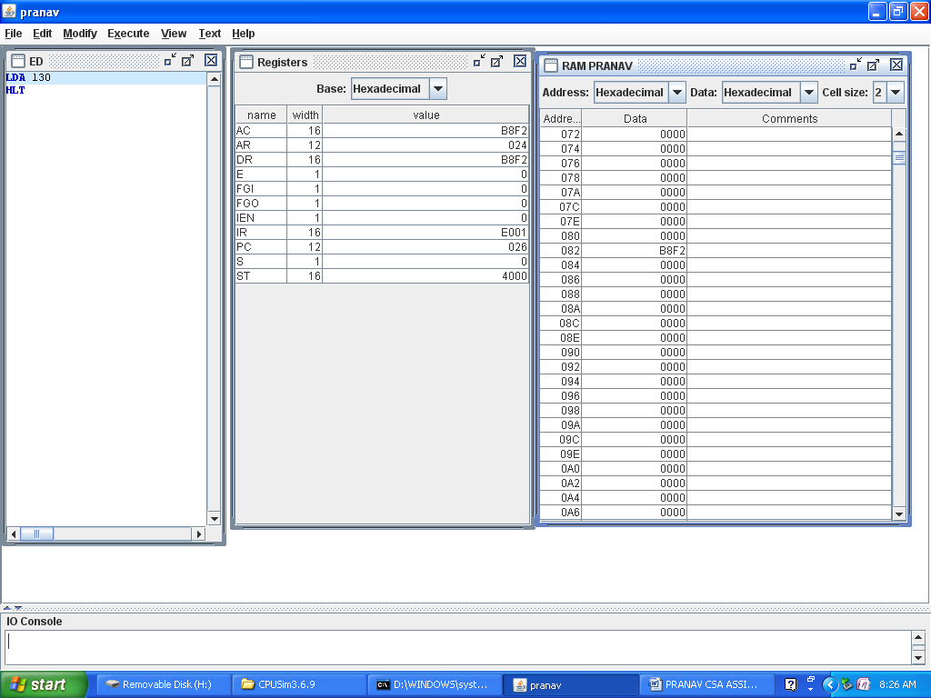

1. **STA**

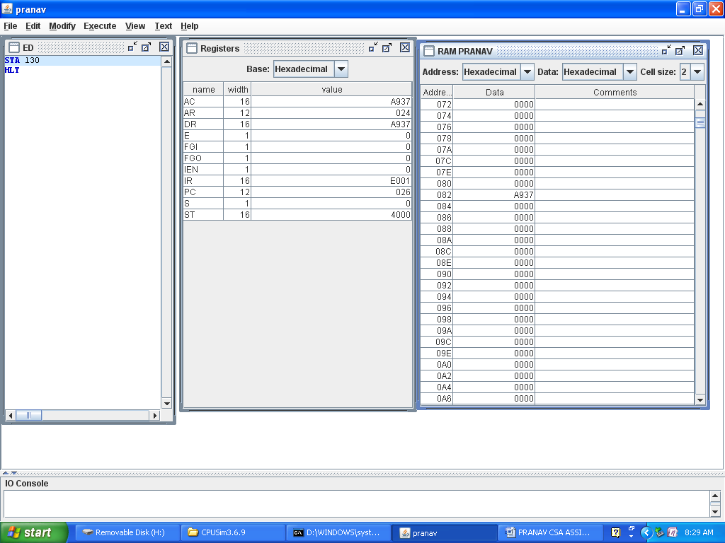

**e.bun**

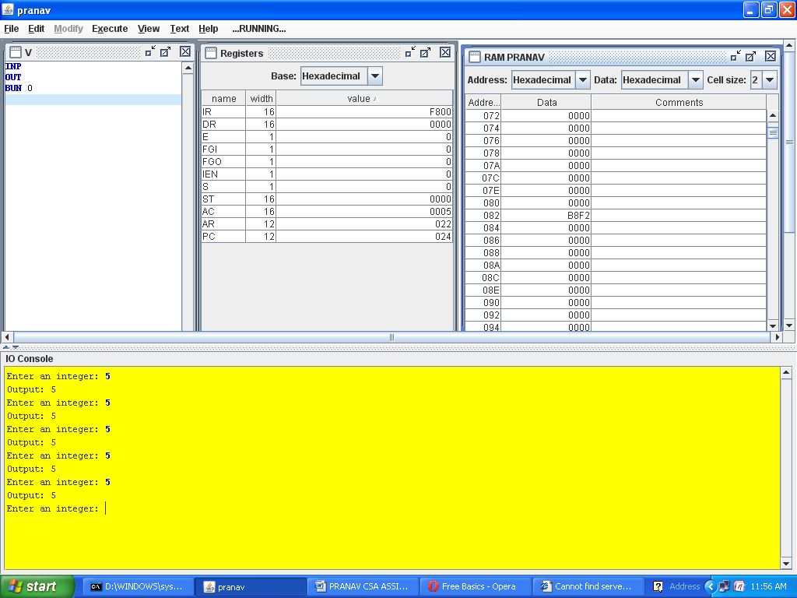

**f.bsa**

**g.ISZ**

**(BEFORE ISZ)**

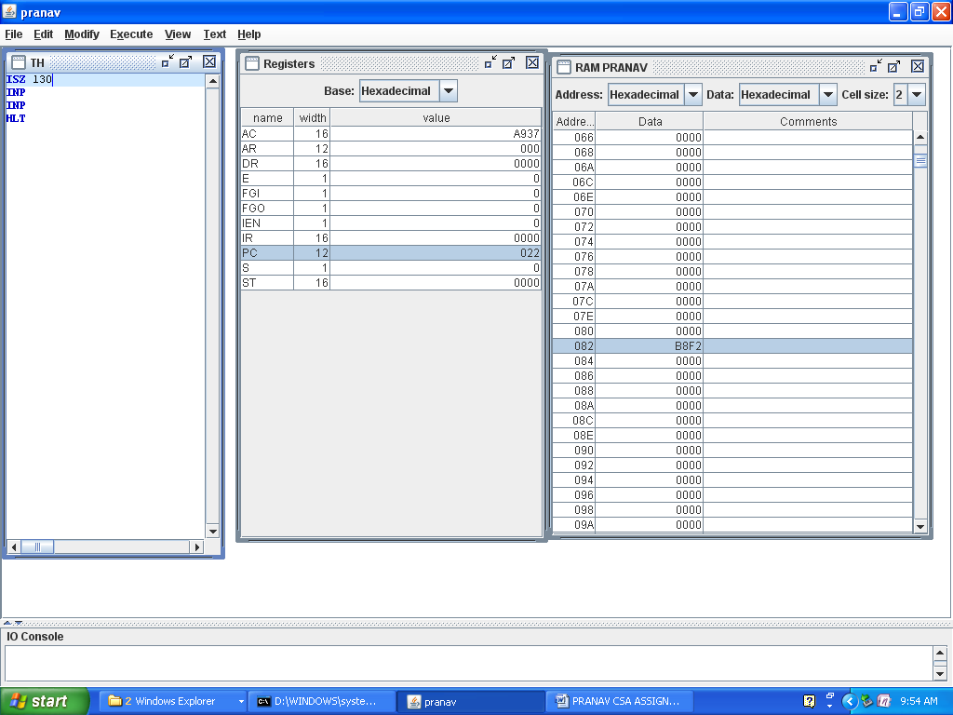

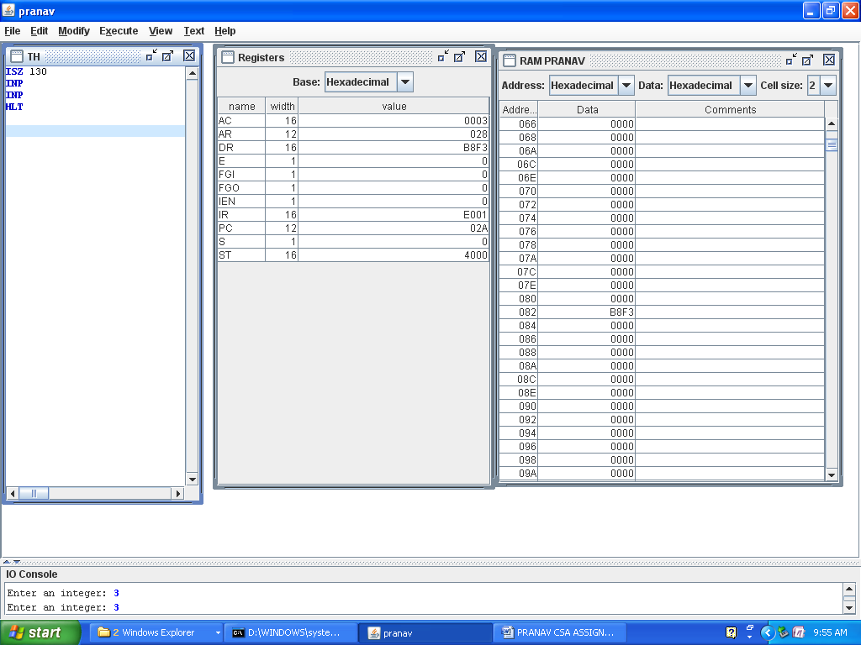

**WHEN DR IS -1**

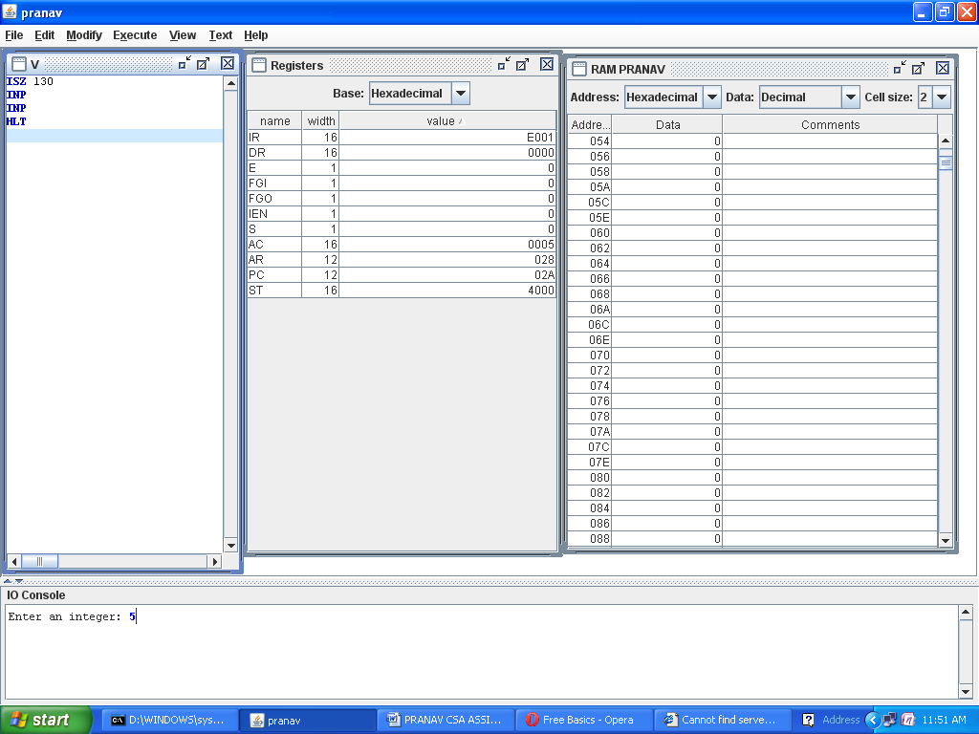

**question 10**

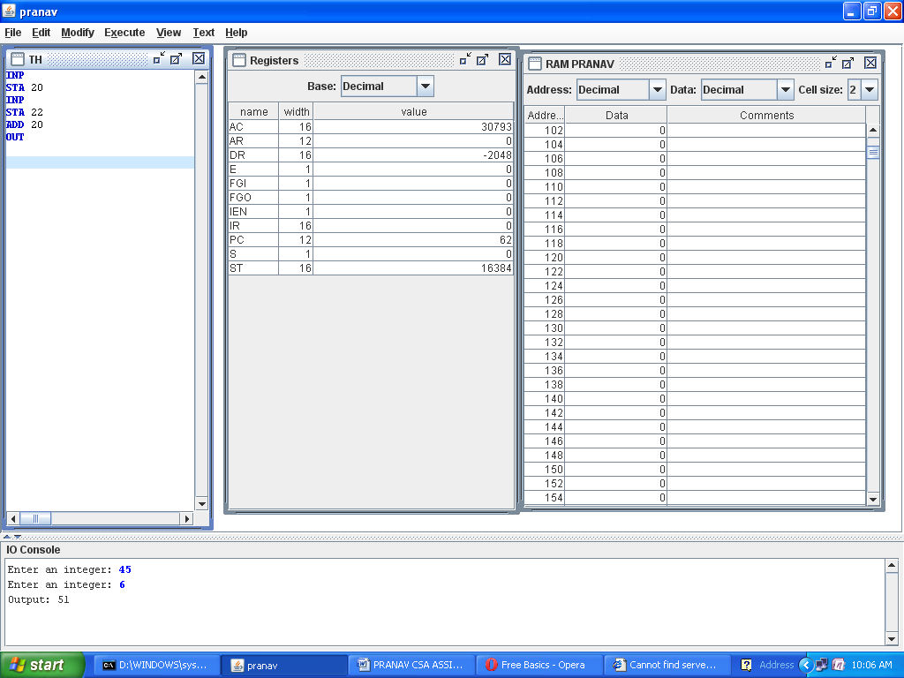

**QUESTION 11 (SUBTRACTION)**

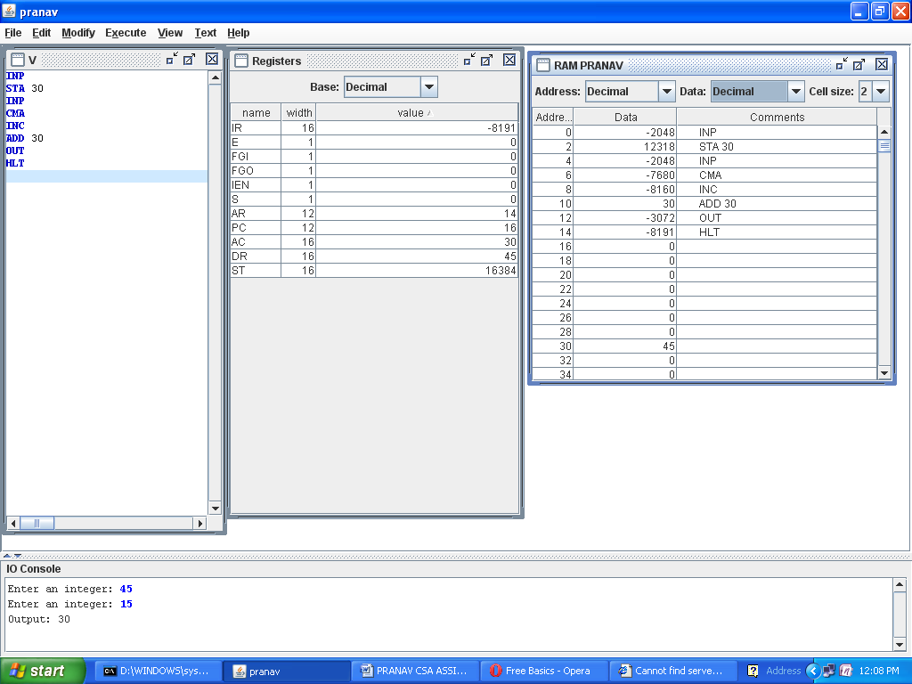

**Ques 12 (Add two no until a zero is entered)**

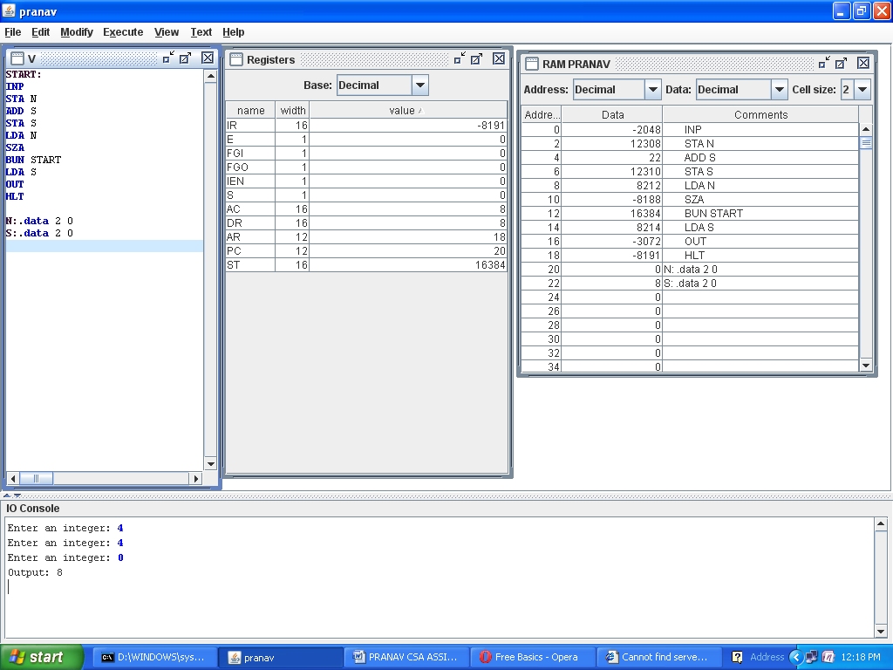

**QUES 13 (MULTIPLY TWO NUMBERS BY SUCCESSIVE ADDITION)**

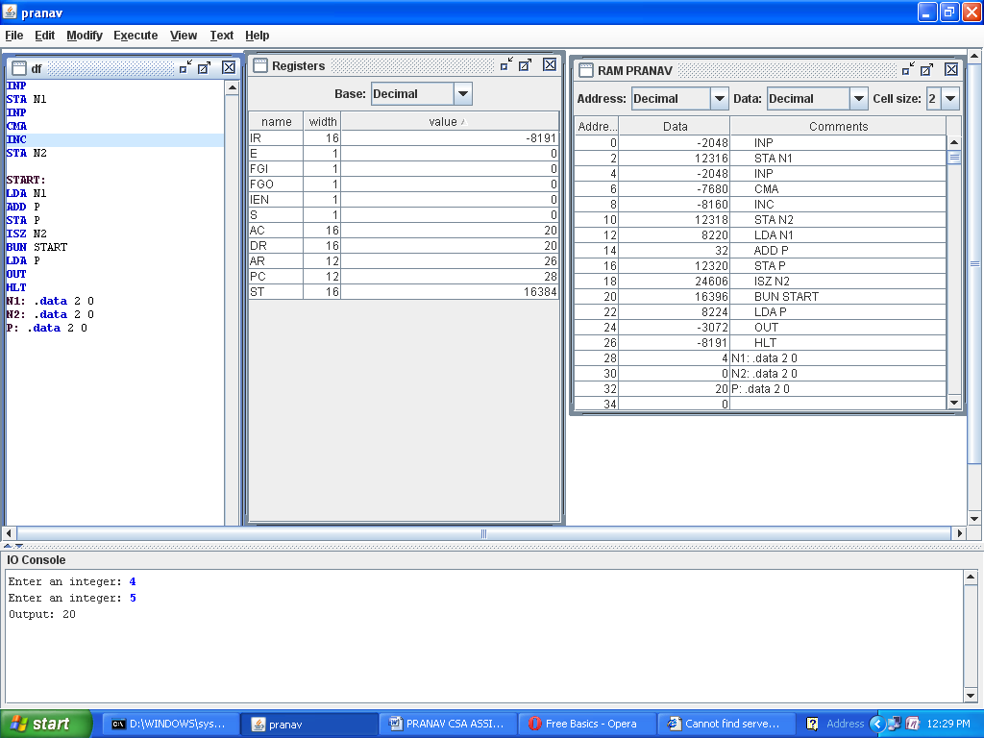

**QUES 14**

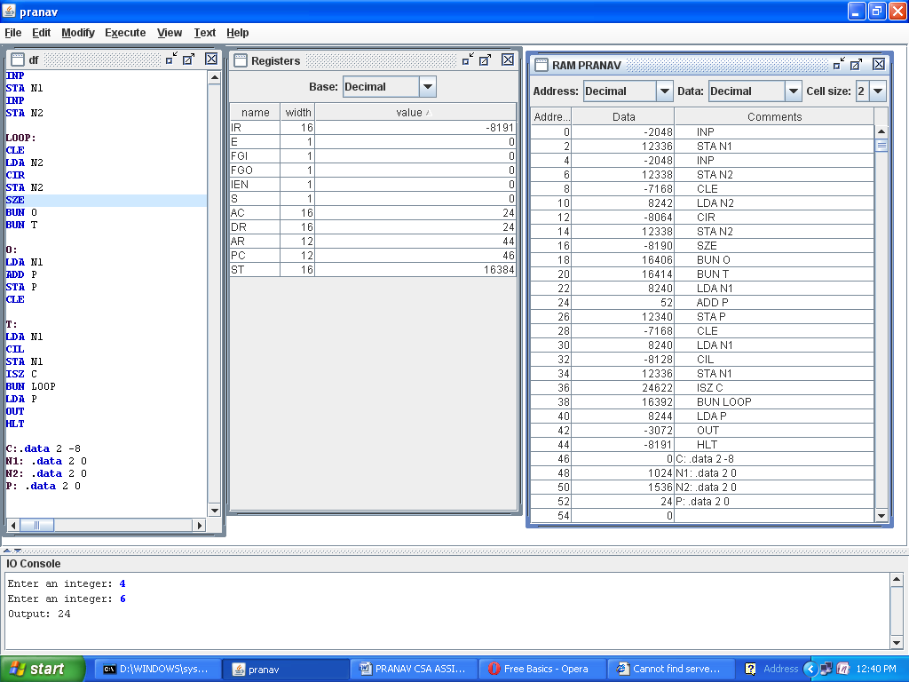

**QUES 5 (INDIRECT)**

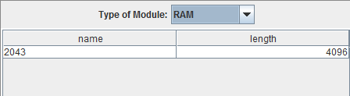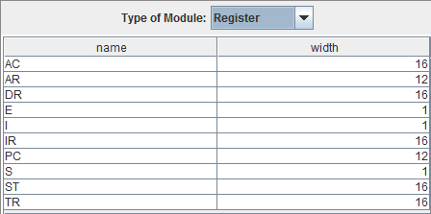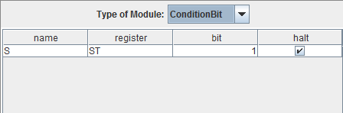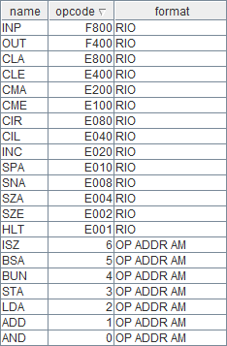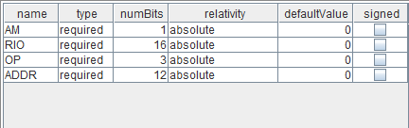QUESTION 6. LIST OF REGISTERS, RAM OF 4096 BYTES, LIST OF MACHINE INSTRUCTIONS OF INDIRECT MAHINE (WITH I-BIT)

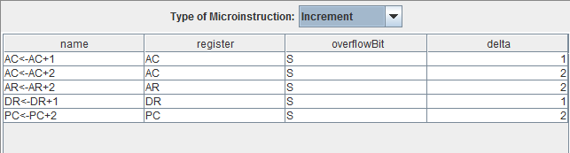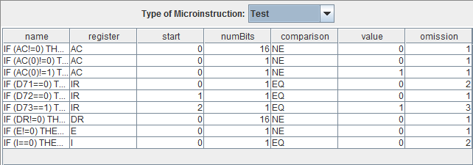LIST OF MICRO-INSTRUCTIONS

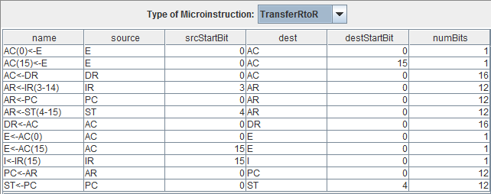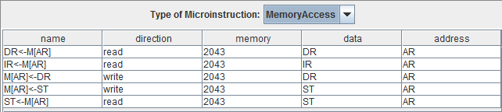



FETCH SEQUENCE FOR INDIRECT MACHINE

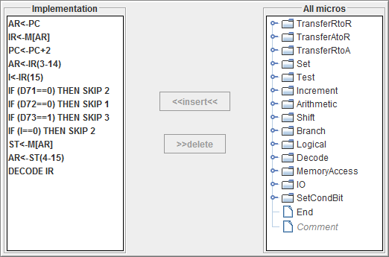

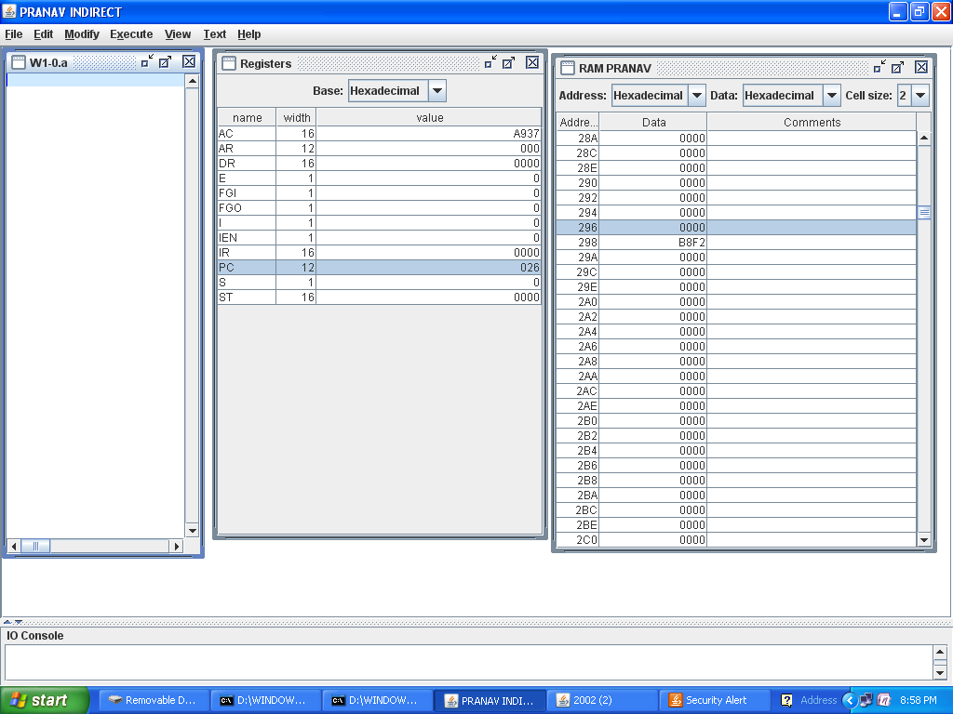

**ADD**

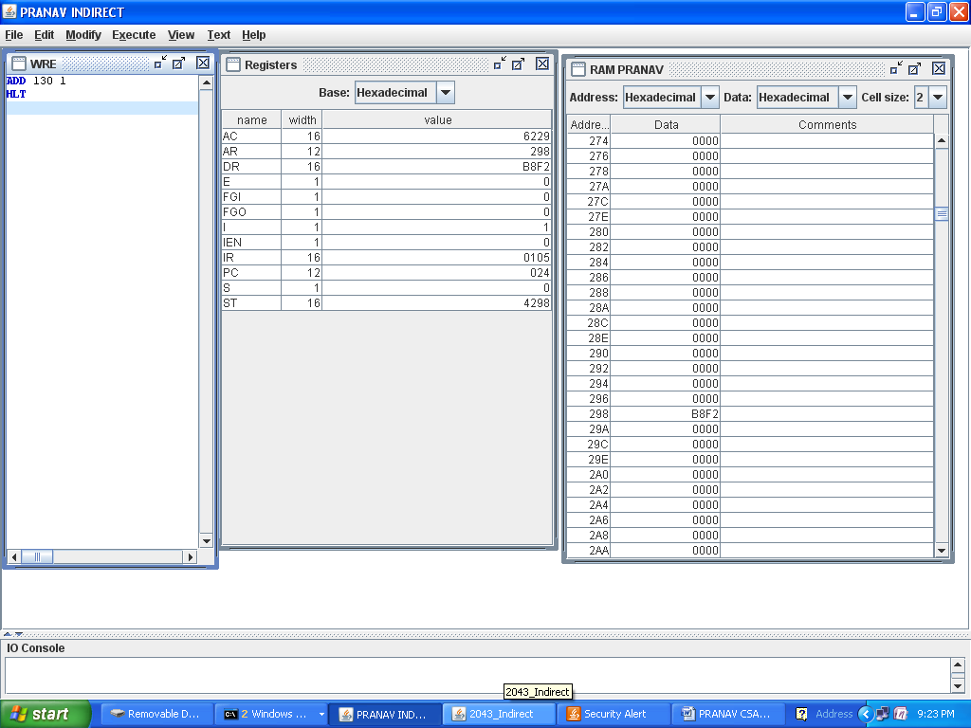

**AND**

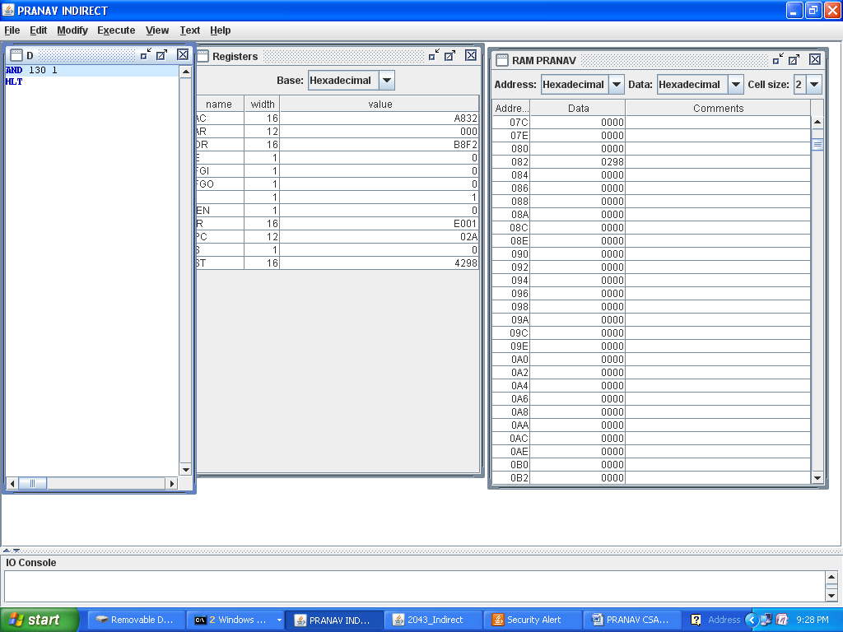

**LDA**

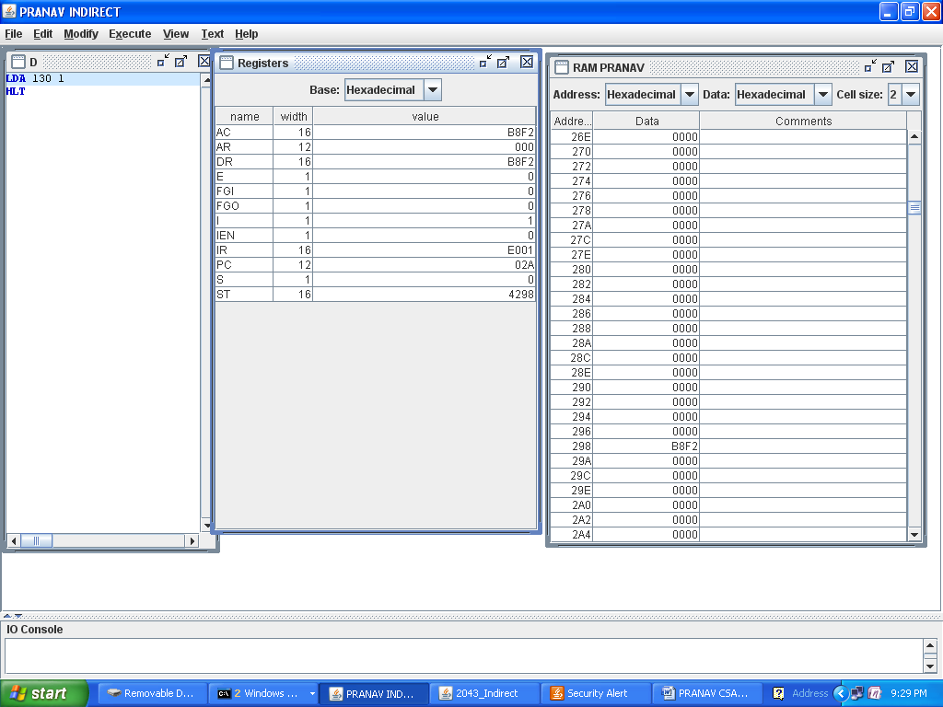

**STA**

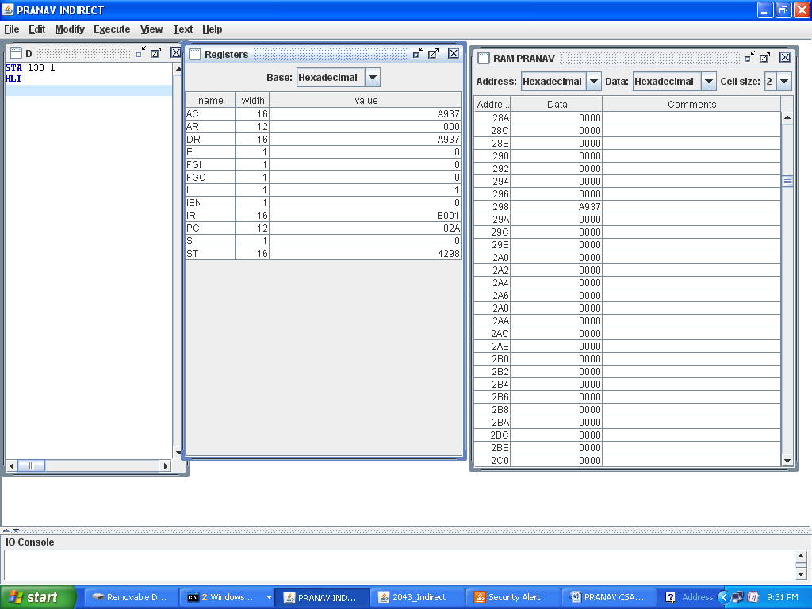

**ISZ**

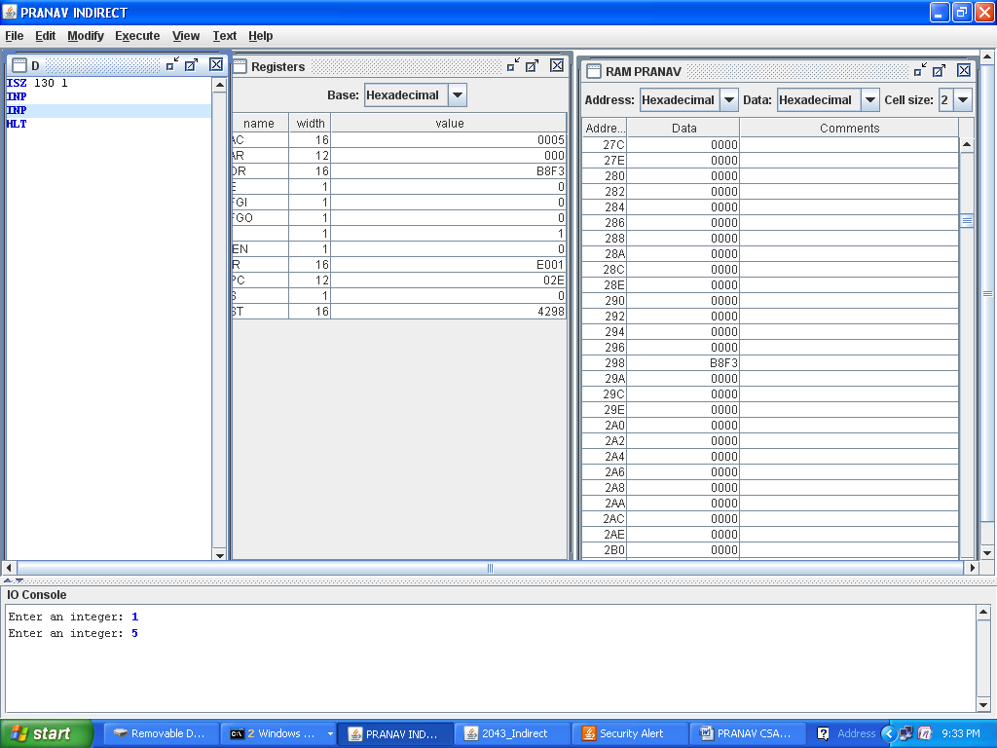

**WHEN DR IS -1.**

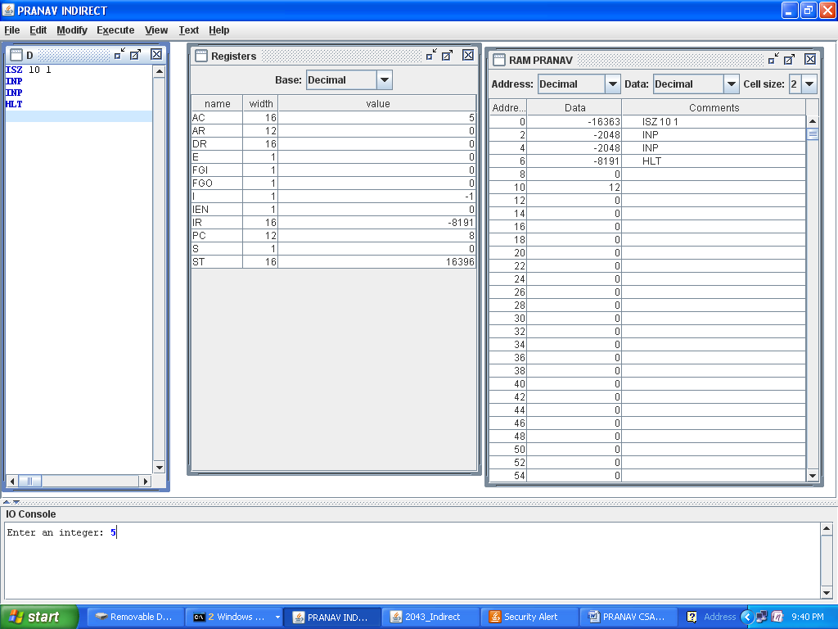

**BUN**

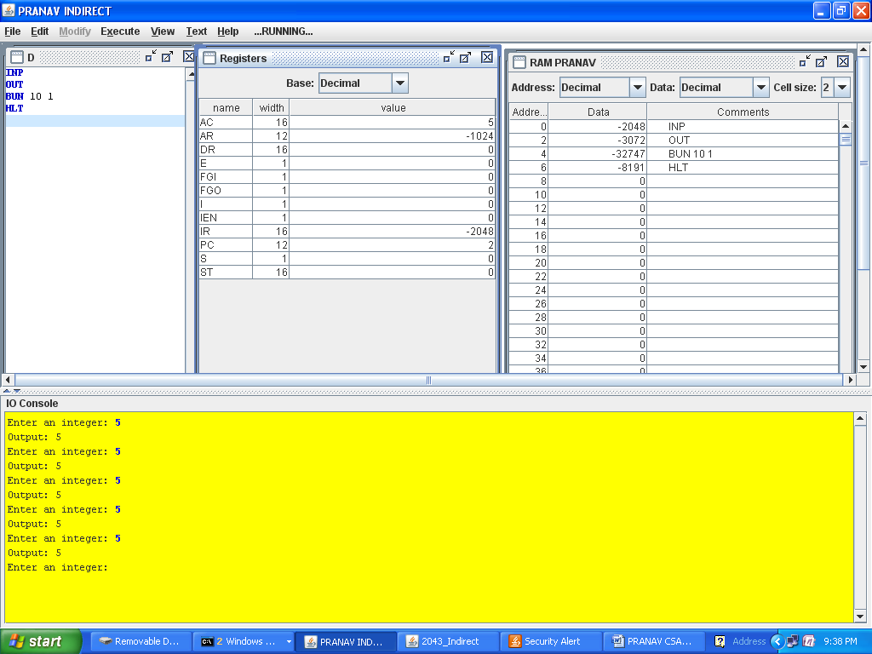

**QUES 9**

**A.REGISTER IS ADDED**

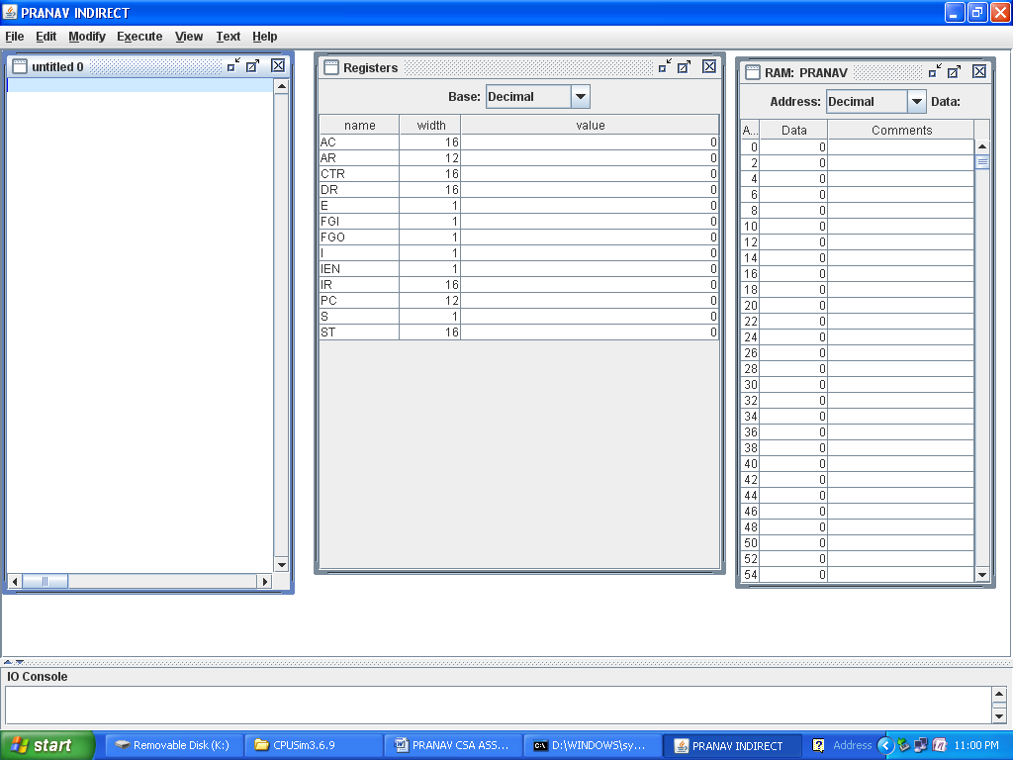

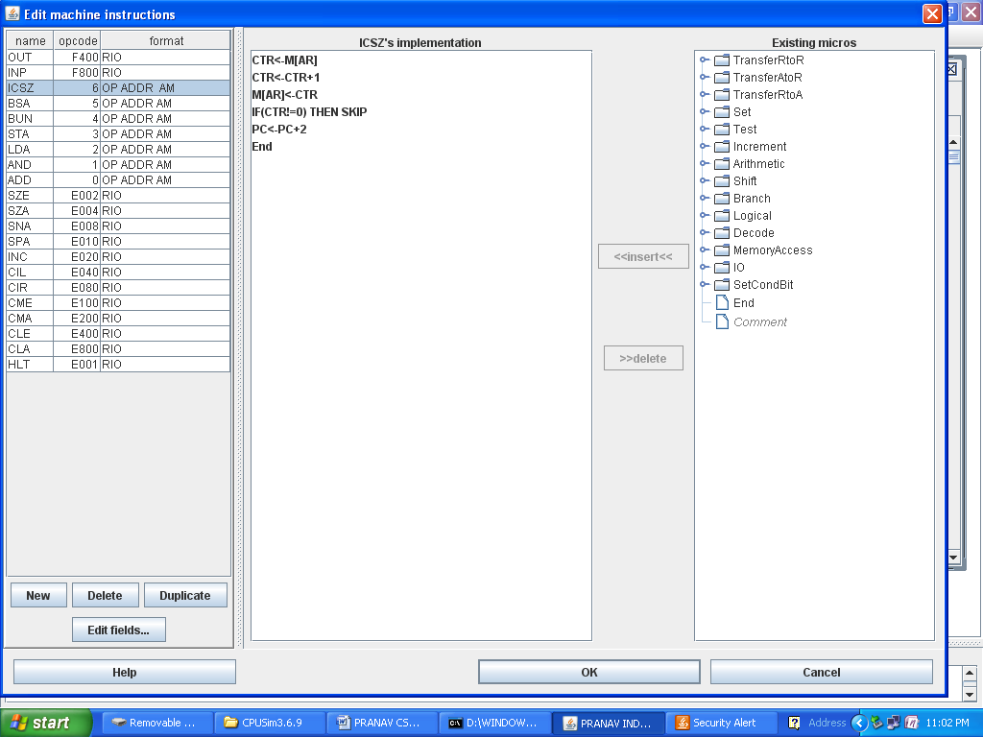

**WHEN -1 IS PLACED IN CTR**

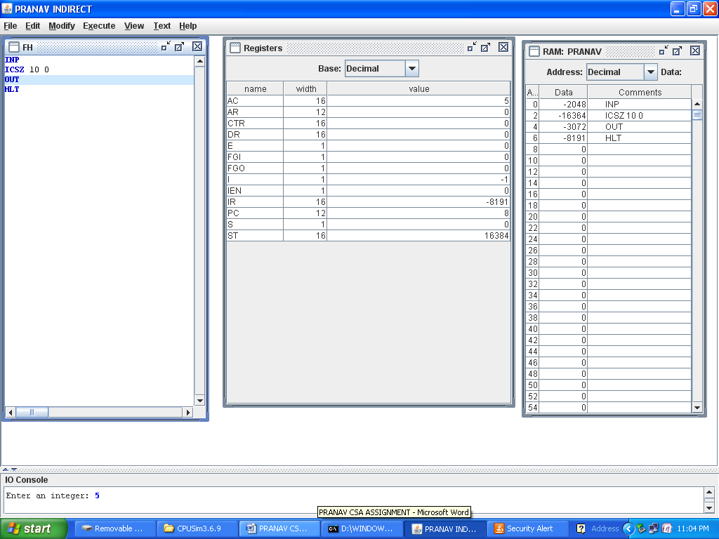

**WHEN ANY OTHER NO PLACED IN CTR**

